What was the origin of the universe?

Since time immemorial we have tried to know how the universe was formed.

**big Bang Theory**

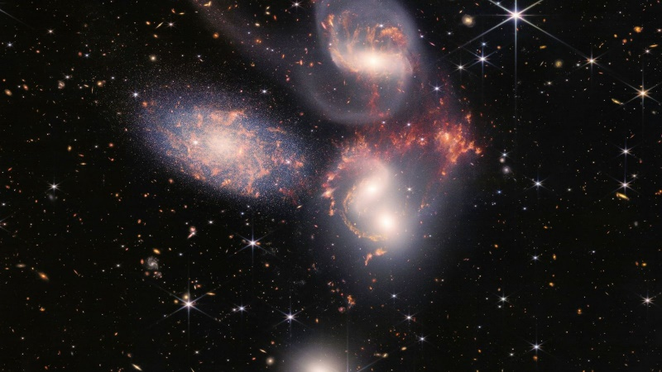

This theory arose from the observation of other galaxies speeding away from our own in all directions, as if they had been repelled by an ancient explosive force.

Before the Big Bang, according to scientists, the vastness of the observable universe, including all its matter and radiation, was compressed into a dense, hot mass only a few millimeters away. This nearly incomprehensible state is speculated to have existed only a fraction of the first second of time.

Proponents of the Big Bang suggest that some 10 to 20 billion years ago, a massive shock wave allowed all known energy and matter in the universe (including space and time) to arise from some unknown type of energy.

The theory holds that, in an instant after the Big Bang, the universe expanded with incomprehensible speed from its pebble-sized origin to astronomical scope. The expansion has apparently continued, but much more slowly, over the subsequent billions of years.

Scientists cannot know exactly how the universe evolved after the Big Bang. Many believe that as time passed and matter cooled, more diverse types of atoms began to form, and that these eventually condensed into the stars and galaxies of our present universe.

**Inflationary theory**

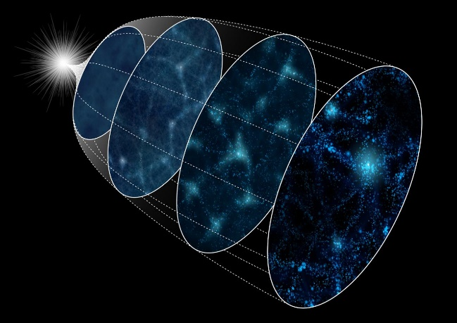

inflationary theory tries to solve the so-called horizon problem, which consists in understanding why, at present, the distribution of matter and radiation in the Universe is practically homogeneous in all its regions.

Inflation suggests that there was a period of exponential expansion in the very pre- primeval Universe. The expansion is exponential because the distance between two fixed observers increases exponentially, due to the expansion metric of the Universe. The physical conditions from one moment to the next are stable: the expansion rate, given by the Hubble constant, leading to high levels of symmetry. Inflation is often referred to as a period of accelerating expansion because the distance between two fixed observers increases at an accelerating rate as they move away from each other.

**Steady state theory**

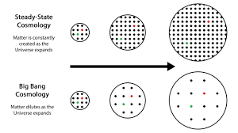

Steady state theory is a cosmological theory proposed in the mid-20th century to account for certain cosmological problems. According to this theory, the decrease in density produced by the expanding universe is compensated by a continuous creation of matter. Because little matter is needed to keep the density of the universe constant as it expands, this hypothesis has not been directly demonstrated. The steady-state theory arises from the application of the so-called perfect cosmological principle, which holds that to any observer, the universe must appear the same anywhere in space. The perfect version of this principle includes time as a variable whereby the universe not only looks the same from any point but also at any instant of time, its general properties being constant in both space and time. The origin of the stationary universe goes back to infinity into the past with an exponential rate of expansion. The rate of expansion tends to zero when time tends to minus infinity.

## Oscillating universe theory

## Qué es la Teoría del Universo Oscilante? - Curiosoando

The oscillating universe is a scientific hypothesis proposed by Richard Tolman, which proposes that the universe undergoes an infinite series of oscillations, each of which begins with a Big Bang and ends with a Big Crunch. The universe expands for a time, before the gravitational attraction of the matter produces an approach, until it reaches a collapse and then undergoes a Big Bounce.

The Big Crunch that exists in the oscillating universe is highly dangerous if it compresses to where we are located, there is a possibility that we also compress but this cannot be confirmed.